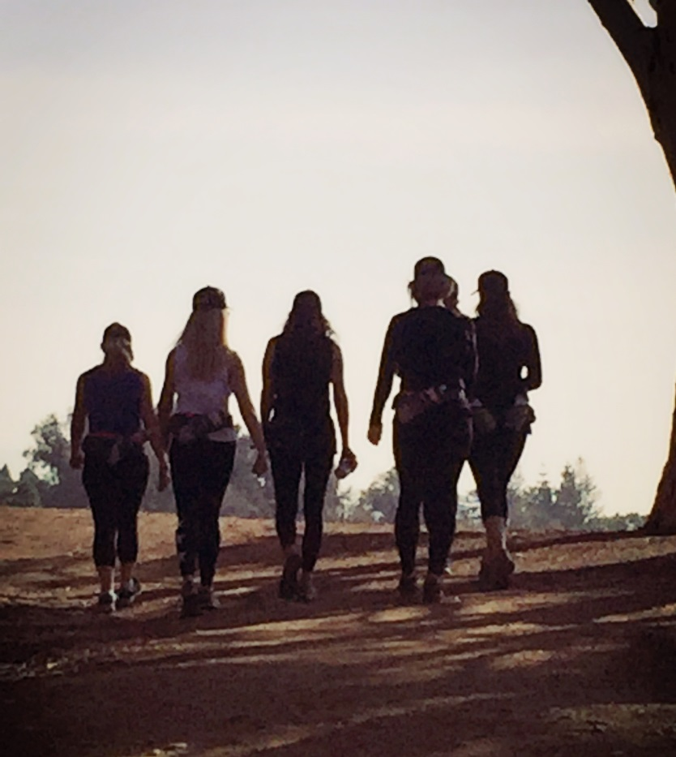

**Join a worldwide revolution of movement... from your own home!**

 Now you can participate in Follow Your Trail... all from the comfort of your own home, office, backyard or the great outdoors, while reaping the benefits of the group dynamic, including all the energy and magic that group participation brings!

**“OFF THE TRAIL”***Online Finding Your Trail Program*

**~ FREE 30 minute Orientation Call**

**~ Zoom Calls**

**~ Private Facebook Group**

**~ Physical Exercise**

**~ Spiritual Awakening**

**~ Emotional Connectivity**

**Begin your journey today!**

**Contact Your Local Coach!**

**Name:**

**Email:**

**Phone:**

**Website:**

## “I believe I deserve to have a life that I love and I also believe you deserve to live the life you love, and for it to be your greatest life!”

**"When you heal yourself, you will be letting  
go of what no longer serves you...**

**and then you can experience joy  
and discover the best version of you.”**